Brandon Lee  
14010627X  
11/20/14  
Lab 9

*Complete project is included. Full working source code can be found there.*

**Problem 1 – Evaluating Breakpoints**

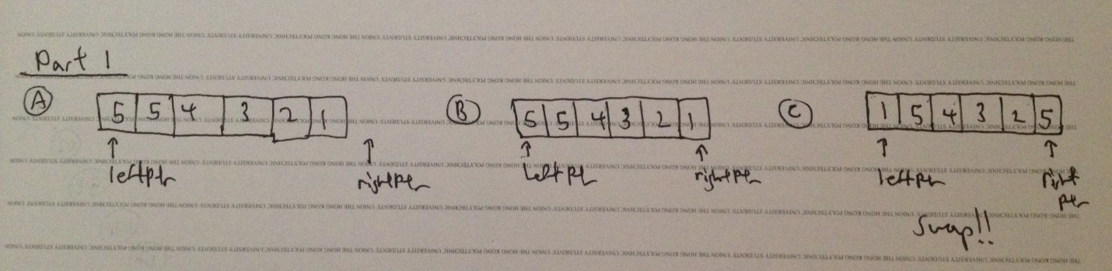

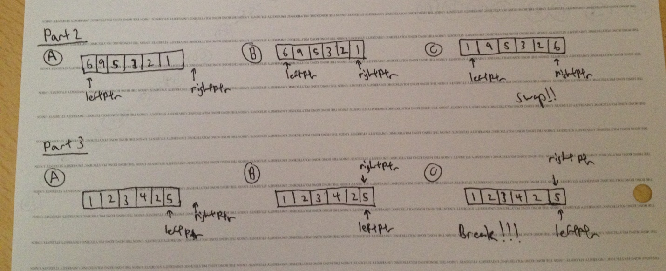

**Problem 2 – Modifying Quicksort**

Initial Array:

A=39 26 53 48 10 12 60 14 66 83 3 65 18 19 85 43

Pivot: 39

A=14 26 19 18 10 12 3 39 66 83 60 65 48 53 85 43

Pivot: 14

A=10 3 12 14 18 19 26 39 66 83 60 65 48 53 85 43

Pivot: 10

A=3 10 12 14 18 19 26 39 66 83 60 65 48 53 85 43

Pivot: 18

A=3 10 12 14 18 19 26 39 66 83 60 65 48 53 85 43

Pivot: 19

A=3 10 12 14 18 19 26 39 66 83 60 65 48 53 85 43

Pivot: 66

A=3 10 12 14 18 19 26 39 53 43 60 65 48 66 85 83

Pivot: 53

A=3 10 12 14 18 19 26 39 48 43 53 65 60 66 85 83

Pivot: 48

A=3 10 12 14 18 19 26 39 43 48 53 65 60 66 85 83

Pivot: 65

A=3 10 12 14 18 19 26 39 43 48 53 60 65 66 85 83

Pivot: 85

A=3 10 12 14 18 19 26 39 43 48 53 60 65 66 83 85

Final Array:

A=3 10 12 14 18 19 26 39 43 48 53 60 65 66 83 85